FCPS
Java
Packets

Unit Five – Data Processing

May 2015

Developed by Shane Torbert
edited by Marion Billington
under the direction of Gerry Berry

Thomas Jefferson High School for Science and Technology

Fairfax County Public Schools

Fairfax, Virginia

Contributing Authors
The author is grateful for additional contributions from Marion Billington, Charles Brewer, Margie Cross, Cathy Eagen, Anne Little, John Mitchell, John Myers, Steve Rose, John Totten, Ankur Shah, and Greg W. Price.

The students' supporting web site can be found at http://academics.tjhsst.edu/compsci/
The teacher's (free) FCPS Computer Science CD is available from Stephen Rose (srose@fcps.edu)

License Information
This work is licensed under the Creative Commons Attribution-Noncommercial-No Derivative Works 2.5 License. To view a copy of this license, visit http://creativecommons.org/licenses/by-nc-nd/2.5/ or send a letter to Creative Commons, 543 Howard Street, 5th Floor, San Francisco, California, 94105, USA.

You are free:

* to Share -- to copy, distribute, display, and perform the work

Under the following conditions:

* Attribution. You must attribute the work in the manner specified by the author or licensor.
* Noncommercial. You may not use this work for commercial purposes.
* No Derivative Works. You may not alter, transform, or build upon this work.
* For any reuse or distribution, you must make clear to others the license terms of this work.
* Any of these conditions can be waived if you get permission from the copyright holder, smtorbert@fcps.edu

You are free to alter and distribute these materials within your educational institution provided that appropriate credit is given and that the nature of your changes is clearly indicated. As stipulated above, you may not distribute altered versions of these materials to any other institution. If you have any questions about this agreement please e-mail smtorbert@fcps.edu
Java Instruction Plan—Unit Five
Section One – Sorting Numbers | Page
Lab00: Find Min, Find Max . . . . . . . . . . . . . . . . . . . . . . . . . . . . . . . . . . . . . . . | Five-3 to 5
Lab01: Selection Sort Algorithm . . . . . . . . . . . . . . . . . . . . . . . . . . . . . . . . . . . | Five-6 to 9
Lab02: Modular Design . . . . . . . . . . . . . . . . . . . . . . . . . . . . . . . . . . . . . . . . . . | Five-10 to 11
Lab03: Scramble and Sort . . . . . . . . . . . . . . . . . . . . . . . . . . . . . . . . . . . . . . . . | Five-12 to 14
Section Two – Sorting Objects
Lab04: Sorting Weights . . . . . . . . . . . . . . . . . . . . . . . . . . . . . . . . . . . . . . . . . . | Five-15 to 16
Lab05: Sorting Distances . . . . . . . . . . . . . . . . . . . . . . . . . . . . . . . . . . . . . . . . . | Five-17
Lab06: Sorting Strings . . . . . . . . . . . . . . . . . . . . . . . . . . . . . . . . . . . . . . . . . . . | Five-18
Lab07: Stu's Used Car Lot . . . . . . . . . . . . . . . . . . . . . . . . . . . . . . . . . . . . . . . . | Five-19 to 20
Section Three – String Parsing
Lab08: EMail Addresses . . . . . . . . . . . . . . . . . . . . . . . . . . . . . . . . . . . . . . . . . . | Five-21 to 24
Lab09: Package Names . . . . . . . . . . . . . . . . . . . . . . . . . . . . . . . . . . . . . . . . . . . | Five-25
Lab10: Musical Strings . . . . . . . . . . . . . . . . . . . . . . . . . . . . . . . . . . . . . . . . . . . | Five-26
Section Four – Recursion
Lab11: Recursive Computations . . . . . . . . . . . . . . . . . . . . . . . . . . . . . . . . . . . . | Five-27 to 29
Lab12: Folder Listing . . . . . . . . . . . . . . . . . . . . . . . . . . . . . . . . . . . . . . . . . . . . | Five-30
Lab13: Towers of Hanoi . . . . . . . . . . . . . . . . . . . . . . . . . . . . . . . . . . . . . . . . . | Five-33
Lab14: Fractal Trees . . . . . . . . . . . . . . . . . . . . . . . . . . . . . . . . . . . . . . . . . . . . . | Five-34 to 35
Lab15: Binary Search . . . . . . . . . . . . . . . . . . . . . . . . . . . . . . . . . . . . . . . . . . . . | Five-36
Discussion
Index versus Value
Let's identify the features of an array declared as double[] array = new double[100];
 |  |  | [0] | [1] | [2] | [3] | [4] |  |  | [99]
array |  |  | 138.35 | 748.15 | 20.51 | 800.01 | 390.02 | … |  | 680.41
array is a reference, or a pointer, to a block of 100 cells, numbered from 0 to 99.
The index is the location or position of the cell. The value is the data itself.
By using the index numbers and the array's subscript [] notation, you can access the array's values, for example, array[index]. These array[subscript] values can be used like any other values. In sorting and searching, we will often be comparing such subscripted values.
Looking at the array above, what is the output of (array[0] < array[2])? _________
Of (array[1] > array[2])? _____________
Below are two loops. Describe in words what each one does.
int index = 0;
for (int k = 0; k < array.length; k++)
index = k;

double d = 0;
for (int k = 0; k < array.length; k++)
d = array[k];

This is a good place to recall Unit 4, Lab08. Notice the difference in use between wordlist[x] and x.
for (int x = 0; x < array.length; x++)
if (myWord.equals(wordlist[x])
System.out.println(wordlist[x] + " was found at " + (x+1));
If all you know is the value, then you cannot quickly determine its index. For one thing, there may be duplicate copies of that value and thus no unique index. Even if the value is unique, finding the index would require a loop, which could take a long time to run.
So, given the choice, you'd always rather know just the index than the value—because if you have the index, you can always get the value whenever you need it.
Using the array above, how would you locate the minimum value by using only the indexes (indices)?

Lab00
Find Min, Find Max
Objective
Using index numbers to search an array.
Background
In the methods we do not explicitly use the values, but instead we find and save the index. In other words, in the methods, we don't care what the min and max are, but we do care where they are. Later, in the main, we use the index to display the actual values of the max and min.
Lines 7-12: As in Unit 4, the data comes from a text file named data.txt. The first line of data (Line 8) tells the size of the array. Line 9 creates that array. Lines 10-11 store the data from the text file into the array.
1 import java.io.*; //the File class
2 import java.util.*; //the Scanner class
3 public class Driver00
4 {
5 public static void main(String[] args) throws Exception
6 {
7 Scanner infile = new Scanner(new File("data.txt"));
8 int numitems = infile.nextInt();
9 double[] array = new double[numitems];
10 for(int k = 0; k < numitems; k++)
11 array[k] = infile.nextDouble();
12 infile.close();
13 int minPos, maxPos;
14 minPos = findMin(array);
15 maxPos = findMax(array);
16 System.out.println("Minimum value: " + "?????");
17 System.out.println("Maximum value: " + "?????");
18 }

19 private static int findMin(double[] apple)
20 {
21 /************************/
22 /* */
23 /* Your code goes here. */
24 /* */
25 /************************/
26 }
27 private static int findMax(double[] banana)
28 {
29
30
31
32
33 }

Line 13: The values are doubles but we will find them through the index, which is an integer.

Line 14: call the return method and pass the data.

Lines 16-17: Your solution should not display question marks. It should output the value of the max and min.

Line 19: The method is private because we don't want outsiders to use it.

Line 19: The argument to findMin is named apple. "apple" is a local reference to "array". In other words, "apple" is an alias for "array." What it means is that apple and array point to the very same array! The same situation applies in Line 27 for banana .

Specification
Write Unit5\Lab00\Driver00.java. Enter the source code shown above. Write the methods findMin and findMax, using index numbers, not values. Then values on Lines 16 and 17.

Filename: Unit5\Lab00\data.txt is given to you.
Test Data
Go to http://academics.tjhsst.edu/compsci/CSweb/index.html
Exercises
Lab00
These code fragments all manipulate the array's values through the array's index numbers. The only way to figure out what's happening to the values and the indexes is to draw a picture of each array:
 |  |  | [0] | [1] | [2] |  |  | [array.length - 1]
array |  |  |  |  |  | …

1) Write the contents of circle after this code has run:
[0] | [1] | [2] | [3]
1.0 | 10.0 | 1.0 | 0.0
double[] circle = {1.0, 10.0, 1.0, 0.0};
for (int index=0; index < circle.length; index++)
circle[index] =
circle[index] * circle[index] * Math.PI;

2) Write the contents of array after this code has run:
[0] | [1] | [2] | [3] | [4]
1.0 | 5.0 | 2.0 | 3.0 | 5.0

double[] array = {1.0, 5.0, 2.0, 3.0, 5.0};
for (int pos = array.length - 1; pos > 0; pos--)
array[pos] = array[pos - 1];

3) Write the contents of myArray after this (useless) code has run:
[0] | [1] | [2] | [3] | [4] | [5] | [6]
3 | 2 | 6 | 1 | 9 | 2 | 1
temp
int[] myArray = {3, 2, 6, 1, 9, 2, 1};
for (int i=0; i< myArray.length - 1; i++)
if (myArray[i] > myArray[i + 1])
{
int temp = myArray[i];
myArray[i] = myArray[i + 1];
myArray[i + 1] = temp;
}

4) What is the output of this (useless) code?
[0] | [1] | [2] | [3] | [4]
1 | 2 | 3 | 4 | 5
int[] myList = {1, 2, 3, 4, 5};
changeArray(myList);
System.out.print("The changed list is ");
for (int i=0; i< myList.length; i++)
System.out.println(myList[i] + " ");

public static void changeArray(int[] tempList)
{
for (int i=0; i < tempList.length; i++)
tempList[i] = tempList[i] + tempList[2];
}

Discussion
Selection Sort Algorithm
Searching and sorting are important and well-studied topics in computer science. In the last lab, you learned how to find a max or a min in an array, which is an example of searching. In Unit 4 you searched a list of words for a match. This lab shows you a sorting algorithm called the Selection Sort. Here is the algorithm:

Repeat N – 1 times, where N is the size of the data set:
1) Find the index of the maximum value in the unsorted part of the array. (Remember Lab00.)
2) Swap the value of the max and the value at the end of the unsorted part of the array.

Here is a table showing how the Selection Sort moves the values around. Only underlined values are being swapped. The bold values are known to be in their proper position.

begin: | 3 | 1 | 4 | 1 | 5 | 9 | 2 | 6
pass 1: | 3 | 1 | 4 | 1 | 5 | 6 | 2 | 9
pass 2: | 3 | 1 | 4 | 1 | 5 | 2 | 6 | 9
pass 3: | 3 | 1 | 4 | 1 | 2 | 5 | 6 | 9
pass 4: | 3 | 1 | 2 | 1 | 4 | 5 | 6 | 9
pass 5: | 1 | 1 | 2 | 3 | 4 | 5 | 6 | 9
pass 6: | 1 | 1 | 2 | 3 | 4 | 5 | 6 | 9
pass 7: | 1 | 1 | 2 | 3 | 4 | 5 | 6 | 9

After values are put at the end of the array, they are in sorted order, and are not considered further. It is possible that an item is swapped with itself. Notice that if we have N items, then we only need N-1 passes in the outer loop. The inner loop visits each element 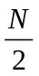times. In the general case, how many comparisons are needed in the Selection Sort? _______

In your own words write the algorithm for Selection Sort.

Lab01
Selection Sort Algorithm
Objective
Code the Selection Sort.
Background
Repeat N – 1 times, where N is the size of the data set:
1. Find the position of the max in the unsorted part of the array.
- Swap the max in the unsorted part with the last item in the unsorted part.

Trace this algorithm for the data shown below.
begin: | 2.0 | 3.7 | 9.9 | 8.1 | 8.5 | 7.4 | 1.0 | 6.2
pass 1:
pass 2:
pass 3:
pass 4:
pass 5:
pass 6:
pass 7:
How many for-loops do you need? ____ Are they nested? Y / N

Assume they both start at index 0 (of course!). At what value does the outer loop stop? __________

The inner loop needs to stop before the sorted part of the array. What value is that? _____________

How will you accomplish the "swap" routine? You will need a helper variable. You will need three assignment statements. Write them below, using the variables shown.
9.9
6.2
array[maxPos]
array[index-1]
________________________________

________________________________

temp

________________________________
Specification
Filename Unit5\Lab01\Driver01.java. An unsorted array is given to you. Sort the array using the Selection Sort algorithm, above. Print out the sorted array. JGrasp's debugger lets you see the values moving around.

Extension
Read and sort Lab00's data by using the relative filepath "..\\Lab00\\data.txt" (Unix computers use "../Lab00/data.txt" ). As in Unit 4, Lab06, output the sorted data to the text file "output.txt".
Test Data
Go to http://academics.tjhsst.edu/compsci/CSweb/index.html
Exercises
Lab01
Answer these questions.

1) private static double findMax(double[] arg)
{
double max = arg[0];
for(int k = 1; k < arg.length; k++)
max = Math.max(max, arg[k]);
return max;
}

- This findMax returns the max value in a given array. Why is this not helpful to a selection sort?

- What would we then have to do, knowing the max value, to actually make a selection sort work?

c) Re-write the method so that it returns the index of the maximum value.

2. Here is a student's code for a selection sort to order the array from greatest to least. The student is trying to find the minimum value and swap it to the end of the array.
21 for(int k = 0; k < numitems; k++)
22 {
23 int minPos = 0;
24 for(int j = 1; j < numitems; j++)
25 if(array[j] < array[minPos])
26 minPos = j;
27 double temp = array[numitems - k - 1];
28 array[numitems - k - 1] = array[minPos];
29 array[minPos] = temp;
30 }
- Which lines contain the code for finding the location of the minimum value? _____
- Which lines contain the code for swap? __________
- This selection sort method has a bug. The bug results in a logic error, not a syntax error. What is the problem and what do we need to change in order to make this sort work?

3. Write from memory the routine to swap values at two given locations, i and j, in an array.

Exercises
Lab01 continued
We need to review some concepts and terminology regarding methods. Look at Unit 5, Lab00 and answer:
- How do you recognize a void method? Give an example from Unit 5, Lab00.

- How do you recognize a return method? (There are two indicators.) Give an example from Lab00.

- How do you call a void method? Give an example from karel.

- How do you call a method that returns an int? Give an example from Lab00.

- In Lab00, what is the type of the argument to findMin(double[] apple)? ___________
- How do you pass an argument into findMin(double[] apple)?

- In Lab00, what is the global name of the array outside findMin? _________
- In Lab00, what is the local name of the array inside findMin? ________________
- If the argument to findMin is an array of doubles, why are we returning an int?

- Does the loop in findMin go <= array.length or just < array.length? _______ Why?

- Headers communicate lots of information. Explain everything communicated by this header:
private static void scramble(double[] array, int howManyTimes)

- Explain everything communicated by this header:
public int compareTo(Object arg)
Lab02
Modular Design
Objective
Selection sort with methods.
Background
Top down programming is a way to break a complicated problem into parts. It means you break a problem into its tasks, which later become the methods. Then you break each task into sub-tasks. If necessary, you keep breaking the tasks into smaller pieces, and finally each piece is small enough to write the code directly. Then you put the pieces together.
Actually, you do this in your daily life all the time. One common daily task, for example, is to go to school. But if you think about it, that task is actually several sub-tasks. Subtask 1 is to get out of bed. Subtask 2 is to eat breakfast. Subtask 3 is to drive to school. But wait—each of those subtasks can themselves be divided into several sub-sub-tasks. For example, "to eat breakfast" is to get the milk, cereal, bowl, and spoon. But how do you get the milk? Clearly, we could turn each task into ever more detailed subtasks, until it becomes something that you "just know" how to do. At that point, you are ready to write the code.
Suppose we were writing a go-to-school program in Java. We would turn the list of tasks into the main:
public static void main(String[] args)
{
Person me = new Person(); //instantiate the objects
Bus bus = new SchoolBus();
getOutOfBed(me); //call the class methods
eatBreakfast(me);
driveToSchool(bus);
}

This is a Level 1 design. The next step is to write Level 2, the subtasks. For eatBreakfast we have:
private static void eatBreakfast(Person p)
{
p.getMilk(refrigerator); //call Person’s instance methods
p.getCereal(cabinet);
p.getBowl(cabinet2);
//etc.
}

Computer scientists follow this divide-and-conquer strategy all the time. Let's use the top-down design strategy to solve the problem of sorting an array of numbers into order.
Specification
Filename Unit5\Lab02\Driver02.java. Read a given number of doubles from a text file. Use a Selection Sort to sort them into ascending order. Output the sorted array into another text file.
The specification describes three major tasks. What are they? These tasks become the method calls in the main. After that, you turn your attention to the subtasks. What are the subtasks for, e.g. sort ?
Test Data
Go to http://academics.tjhsst.edu/compsci/CSweb/index.html
Exercises
Lab02
Answer each question about Lab02.
- Write the header of the swap method.
- What are the types of the three arguments in the swap method?
- Give three reasons why programmers break up a program into methods.

Do a Level 1 top-down design for the problems below. That is, write the main() only.
3) Read in an unknown number of integers from a text file and print out all the numbers that are strictly greater than the average value. The three tasks are _____________, ______________, and _____________.
public static void main(String[] args) throws Exception
{
int[] array = ____________("input.txt"); //reads in data from file
double avg = ___________( _______); //finds the ___________
_________(array, avg); //displays those values in array that are
// greater than avg
}
4) Write the method calls in main to: read in a month's worth of daily high and low temperatures, find the maximum and the minimum, and output those two numbers. Do not write the methods themselves.

- Write the method calls in main to: read in an arithmetic expression, e.g. 2+3*4, check to make sure that it is well-formed, and if the check is good, then evaluate and output the answer. If the check is not good, output an error message “arithmetic expression parse error.” Do not write the methods themselves.

Discussion
Bubble Sort
Imagine air bubbles bubbling up to the top of a water cooler. The bubble sort makes the smaller items "bubble up" to the top of the array. Conversely, the larger items "bubble down" to the bottom of the array.

We can start from the end (or the bottom) of the array, which means that k begins at array.length-1. Compare elements side-by-side (that is, compare array[k-1] and array[k]) and if the second one is smaller, swap them. Compare the next pair and swap if necessary. Keep going. Then make another pass.

 | begin: | after  pass 1: | after  pass 2: | after  pass 3: | after  pass 4: | after  pass 5: | after  pass 6: | after  pass 7:
 | 6 | 1 | 1 | 1 | 1 | 1 | 1 | 1
 | 2 | 6 | 1 | 1 | 1 | 1 | 1 | 1
 | 9 | 2 | 6 | 2 | 2 | 2 | 2 | 2
 | 5 | 9 | 2 | 6 | 3 | 3 | 3 | 3
 | 1 | 5 | 9 | 3 | 6 | 4 | 4 | 4
 | 4 | 1 | 5 | 9 | 4 | 6 | 5 | 5
array[k-1] | 1 | 4 | 3 | 5 | 9 | 5 | 6 | 6
array[k] | 3 | 3 | 4 | 4 | 5 | 9 | 9 | 9

The Bubble Sort takes many more swaps than the Selection Sort. In addition, the code checks every item on every loop. (Recall that the inner loop of the Selection Sort checks one less item on each loop.) For both these reasons, the Bubble Sort is slower than the Selection Sort.
How many for-loops does the Bubble Sort require? _________ Are they nested? Y / N

Given N items, the outer loop repeats N times. The inner loop makes 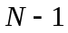comparisons. In the general case, how many comparisons are made in all? ________

In your own words, write the algorithm for the Bubble Sort.
Discussion
Insertion Sort
How do you normally sort a hand of cards? Most people use the Insertion Sort. They get a couple of cards sorted, then put the next card in its proper place, and the next, and so on.
Here is a more formal algorithm: loop forward across the data. For each new item of data (the underlined item), take the item out, compare to its neighbor, and if necessary slide the neighbor over. Compare to the next neighbor and slide if necessary. Eventually the item will be less than a neighbor, meaning that it has reached the correct place, so insert it.
begin: | 3 | 1 | 4 | 1 | 5 | 9 | 2 | 6
pass 1: | 1 | 3 | 4 | 1 | 5 | 9 | 2 | 6
pass 2: | 1 | 3 | 4 | 1 | 5 | 9 | 2 | 6
pass 3: | 1 | 1 | 3 | 4 | 5 | 9 | 2 | 6
pass 4: | 1 | 1 | 3 | 4 | 5 | 9 | 2 | 6
pass 5: | 1 | 1 | 3 | 4 | 5 | 9 | 2 | 6
pass 6: | 1 | 1 | 2 | 3 | 4 | 5 | 9 | 6
pass 7: | 1 | 1 | 2 | 3 | 4 | 5 | 6 | 9

In other words, the Insertion Sort makes sure that all the data it has encountered "so far" is in order. Once it has encountered all the data, then the entire set is sorted. Processing the data takes 2 nested loops, the outer which loops N-1 times and the inner which loops times. In the general case, how many comparisons in all are made in the Insertion Sort? _________ How many comparisons were made in the Bubble Sort? _______ How many comparisons were made in the Selection Sort?_________

Since the efficiency of these three sorts are all of the same order of magnitude, computer scientists classify them as N² or quadratic sorts. In general, if we double the number of items, we quadruple the work to sort them. As an example, if a program sorts 500 items in 3 ms, then we can expect it to sort 1000 items in 12 ms. If we sort 2000 items, about how much time will we expect? ______ How long to sort 4000 items? ______

In your own words, write the algorithm for the Insertion Sort.
Lab03
Scramble and Sort
Objective
Scramble and sort an array of integers.
Background
The task is to print an ordered array, scramble it, sort it into order, and print the ordered array. The main method is planned out in good top-down style:
4 public class Driver03
5 {
6 public static void main(String[] args)
7 {
8 int[] array = {100, 101, 102, 103, 104, 105, 106, 107, 108, 109};
9 print(array);
10 scramble(array);
11 print(array);
12 sort(array);
13 print(array);
14 }
Notice the main is just a list of methods with arguments. Of course, all the real work goes on in the methods.

It is important to realize that the call to the method passes data through its argument(s). For example, the call in main at Line 10 to scramble(array) instructs the computer to run the method scramble using the data in the array.

The method scramble somehow has to receive the data. We specify that the method will be receiving data by coding its header something like scramble(int[] grape) .

Java checks to make sure that the type of the arguments always match up. That is, if you wrote the method with the header scramble(double[] grape), you would get a compile error, something like "cannot apply int[] to double[]". You will learn in the next several labs that whenever you write a method, you must make sure that the data types in the argument list match the data types in the calling method.

Specification
Write the application as given above. Use the Selection sort from Lab02, including its helper methods, but change it so that it handles integers, not doubles. Then write the methods scramble and print. You will need to devise your own algorithm to scramble an array of numbers.

Extensions
- Suppose we wanted to sort in reverse order, that is, from largest to smallest. What changes would we have to make in the code? Do so.
- Implement the Bubble Sort.
- Implement the Insertion Sort.

Test Data
Go to http://academics.tjhsst.edu/compsci/CSweb/index.html
Discussion
The Comparable<E> Interface
Objective
Sorting objects, Java-style.
Background
Since we have just sorted numbers, we turn our attention to sorting objects. We will use the same Selection Sort algorithm, but we must specify what we mean when we say that one object is "bigger than" another. The standard Java way to do so is to write a compareTo method. Put more abstractly, we say that the class implements the Comparable<E> interface. (The E is a placeholder for a class. The E is used only in the API. Look at Line 1 on the next page for an example where <E> is replaced by a concrete class <Weight>.)
The Comparable<E> interface contains a single abstract method compareTo . All the work goes on in the concrete subclass's compareTo , which you will implement in Labs04, 05, and 06. The method compareTo takes one argument of type E and by convention returns a number. Your job as the programmer is to return the correct number. By convention, the returned number indicates either <, ==, or > as follows:
if x.compareTo(y) returns a negative number, it is equivalent to x < y.
if x.compareTo(y) returns zero, it is equivalent to x == y.
if x.compareTo(y) returns a positive number, it is equivalent to x > y.
Often the number returned is –1, 0, or 1, but this is not guaranteed. It could be any negative number or any positive number. In Lab05 and Lab06, we will return other numbers.
To repeat, Java makes us do all this because objects cannot use the built-in arithmetic comparative operators. The conditional if( x < y ) is undefined if x and y are objects. Math.max is also undefined for objects. Java's solution is to use compareTo to compare objects x and y:
if( x.compareTo(y) < 0 )
doSomething();
if( x.compareTo(y) == 0 )
doSomething();
if( x.compareTo(y) > 0 )
doSomething();
But not all objects can be compared. Only those objects that implement the Comparable<E> interface are guaranteed to have a compareTo method. 1) How does Java check for this requirement?

Object

implements
2) Fill in the UML class diagram for Lab04.

uses

3) How does the method findMax(Comparable[] array) illustrate the power of polymorphism?

Lab04
Sorting Weights
1 public class Weight
implements Comparable<Weight>
2 {
3 private int myPounds, myOunces;
4 public Weight()
5 {
6 myPounds = myOunces = 0;
7 }
8 public Weight(int x, int y)
9 {
10 myPounds = x;
11 myOunces = y;
12 }
13 public int getPounds()
14 {
15 return myPounds;
16 }
17 public int getOunces()
18 {
19 return myOunces;
20 }
21 public void setPounds(int x)
22 {
23 myPounds = x;
24 }
25 public void setOunces(int x)
26 {
27 myOunces = x;
28 }
29 public int compareTo(Weight w)
30 {
31 if(myPounds < w.getPounds())
32 return -1;
33 if(myPounds > w.getPounds())
34 return 1;
35 if(myOunces < w.myOunces)
36 return -1;
37 if(myOunces > w.getOunces())
38 return 1;
39 return 0;
40 }
41 public String toString()
42 {
43 return myPounds + " lbs. " +
myOunces + " oz.";
44 }
45 }
The Weight class in Lab04 is a typical example of a class. You should be able to identify the data fields, the constructors, the accessors, the modifiers, and the instance methods. Mark each of these with a letter "F", "C", "A", "M", or "I".
Line 1 says "implements Comparable." What does that mean?
Why does line 1 have "<Weight>"?
Why does line 31 have "w.getPounds()"?
When does line 32 return "-1"?
The w.myOunces on Line 35 works! private means private at the class level, not at the object level.
When does line 38 return "1"?
When does line 39 return "0"?
What does this command return?
array[x].toString();
Specification
Filename Unit5\Lab04\data.txt. Run MakeDataFile to create a file of pounds and ounces. The partial file at right has weights for 57 objects. The first object weighs 64 lbs 13 oz., the second is 15 lbs 12 oz., etc.
57
64
13
15
12
67
3
10
Filename Unit5\Lab04\Weight.java. Copy the code. Study compareTo carefully!
Filename Unit5\Lab04\Driver04.java is partially done. You will have to read the file for pounds and ounces, instantiate a Weight object, and assign it to its place in the array. Also, sort, swap, and findMax all need to work with arrays of type Comparable. (Why?)

Partial Output
0 lbs. 4 oz.
1 lbs. 3 oz.
1 lbs. 12 oz.
2 lbs. 2 oz.
6lb7
3
10
Test Data
Go to http://academics.tjhsst.edu/compsci/CSweb/index.html
Lab05
Weight
myPounds
myOunces
getOunces()
compareTo()

equals()
getPounds()
setPounds()
setOunces()
toString()
Sorting Distances
Objective
Write a Distance class that implements Comparable<E>.

Background
A diagram of the Weight class is shown to the right. Note the private data fields are totally inside the class. (Why?) The modifier methods show arrows going into the class. The accessor methods show arrows leaving the class. Since the three other instance methods are public, they extend outside the class. Since all of them
return a result, they all have arrows leaving the class.

An object's private data should not, in general, be accessed directly. Rather, you should use accessor and modifier methods to deal directly
with the private data. Outside methods should not know or care how
the private data is actually stored. Only the class needs to know how
to store its own data. Encapsulation!

Here is a different way to write Weight's compareTo method. This version of compareTo does not return the signals –1, 0, or 1, but will return the actual difference in ounces:

public int compareTo(Weight w)
{
int myTotal = myPounds * 16 + myOunces; //access my data directly
int wTotal = w.getPounds() * 16 + w.getOunces(); //use w's get() methods
return myTotal – wTotal; //return the difference in ounces
}

When implementing compareTo it is a good idea also to override the equals method originally defined in Object<E>. This guarantees that your compareTo and your equals method will not give different answers.

public boolean equals(Weight arg)
{
return compareTo(arg) == 0;
}
Specification
28
10
9
15
2
31
5
6
11
.
.
.
Copy MakeDataFile from Lab04. Modify it so that it generates random feet and inches. Run it to produce the data.txt file. The partial file at the right has data to make 28 Distance objects. The first object will be 10 feet 9 inches, the second is 15 feet 2 inches, etc.

Write Distance.java. Use Weight as an example. Write compareTo and equals methods modeled on those given above.

Write Driver05.java. Use Driver04 as an example.

Extension
Suppose we wanted to sort the distance objects in reverse order, that is, from largest to smallest. What changes would we have to make in the code? Do so.

Test Data Go to http://academics.tjhsst.edu/compsci/CSweb/index.html
Lab06
Sorting Strings
Objective
To sort strings.
Background
Since strings are objects in Java, the String class also implements the Comparable<E> interface. (Wasn't that nice of the Java developers?) As with single characters, a string is "less than" another if it comes before or earlier, according to the alphabet. What about capital letters and characters that are not in the alphabet? To handle these, programmers have come up with several possible orderings. Java uses a ordering called Unicode (www.unicode.org), which is a superset of the older ASCII ordering. In Unicode, all capital letters come before all lowercase letters. Capital 'A' is number 65 and lowercase 'a' is number 97. Therefore, "A".equals("a") returns false. Also, "A".compareTo("a") returns a negative number.
Did you write a separate sort for Weight and Distance, and are you planning to write a new one for String? If so, you wasted your time. Since all three of these classes implement the Comparable interface, i.e., all three are (also) objects of type Comparable, we only need one general sort:
public static void sort(Comparable[] array)
In both the sort and the findMax methods, the general superclass reference to Comparable[] points to a specific subclass object, either Weight, Distance, or String. The code that actually gets executed is in the subclass object, either Weight, Distance, or String as appropriate. Writing such general methods takes advantage of the power of polymorphism.
In Unit4, Lab08, when you searched for a word in a dictionary, you were looking for "equal" strings. If you remember, you could not use the == symbol. Instead, you had to use the dot-equals method for Objects:
if( s.equals(wordlist[x]) )
For the same reasons, in this lab you cannot use the less-than or greater-than symbols, < or >, to sort the list of words. You must use dot-compareTo because Strings are Comparables, like this:
if( array[j].compareTo( array[maxPos] ) > 0 )
Specification
222
album
vampire
bomb
Triangle
pendulum
record
Film
Tiger
.
.
.
Filename Unit5\Lab06\data.txt. A file of 222 words is provided, beginning like this:
Write Driver06.java. Read the file of words into the array. (Java doesn't have many exceptions to its rules, but here is one: even though a string is an object, it doesn't need to use the new operator.) Then sort the words, using the general Selection Sort. Last, print the sorted array to "output.txt." Why are words with capital letters first in the list?
Test Data
Go to http://academics.tjhsst.edu/compsci/CSweb/index.html

Lab07
Stu's Used Car Lot
Objective
To implement several Comparator<E> interfaces.
Background
What happens if you want to sort the same set of data based on differing criteria? For instance, you may want to sort objects by name sometimes and by size other times. The Comparable interface cannot do this because compareTo defines a single ordering for the class. The solution is to instantiate several Comparator objects whose compare method accepts two objects as arguments and that defines what it means to compare those two objects. The same Selection Sort code, when used with different comparator objects, will produce different ordered lists. Polymorphic behavior!
Each comparator, because it implements the Comparator<E> interface, must define a single method compare that accepts two objects as arguments. Here is an example Comparator that compares the sizes of two Widgets:
public class BySize implements Comparator<Widget>
{
public int compare(Widget arg1, Widget arg2)
{
return arg1.getSize() – arg2.getSize();
}
}
Recall the standard Selection Sort algorithm: find max and swap, find max and swap. In this case, findMax uses the BySize object's compare method to find the Widget with the largest size. swap then swaps the Widgets. At the end, we will have ordered the Widget objects by their sizes. A different comparator object, with a different compare method, would order the Widget objects differently. For example, a ByName object would order the Widget objects alphabetically and a ByPrice object would order the Widget objects by price. In this lab, we will be ordering Salespersons in different ways.
10
Adams
6
8
Brown
4
8
Choi
14
1
Franks
3
1
George
13
12
.
.
.
Specification
Filename Unit5\Lab07\data.txt. A file of 10 names, each followed by two integers, as shown.
Filename Unit5\Lab07\Salesperson.java. Write the constructors, accessors, and modifiers. In contrast to the previous labs, Salesperson is not a Comparable.
Filename Unit5\Lab07\Driver07.java. Study this code. You have seven methods to complete, first input, display, findMin, and swap, then add, search, and save. Notice the clever way to produce the long string message used by JOptionPane.showInputDialog. Notice that save saves the file using a PrintStream object.
Name Cars Trucks Total
----------------------------
Choi 14 1 15
George 13 12 25
Adams 6 8 14
Brown 4 8 12
Miller 5 4 9
Jones 3 6 9
Smith 3 4 7
Nguyen 3 3 6 Thomas 2 20 22
Franks 3 1 4
Filename Unit5\Lab07\ByCars.java. This is an example
Comparator. Study this code, which results in this output:

Write ByTrucks.java.

Write ByTotalSales.java.

Write ByName.java. Hint: a Salesperson's name is a String,
which is a Comparable.
Test Data Go to http://academics.tjhsst.edu/compsci/CSweb/index.html
Lab07
Exercises
1. Labs04, 05, and 06 all used the same sort, findMax, and swap methods, although the data being sorted were different objects. How can the same methods work with three different types of objects?

2. Lab06 on sorting strings contained the line: if(array[j].compareTo(array[maxPos]) > 0)
j is a(n) __________
array[j] refers to a(n) ______________ that is-a ______________ and a(n) ______________
compareTo() is a(n) ________________ of class____________ and of interface ___________
compareTo() returns a(n) ______________
the relational operator ">" returns a(n) __________________
3. Lab07 on Salespersons contained the line: if(c.compare(array[j], array[minPos]) < 0)
minPos is a(n) __________
array[minPos] is-a ________________ and a(n) ________________
if we sort by cars, c is a(n) ___________ of class ________________ which isa ____________
compare() is a(n) ______________________ required by the ________________ interface
compare() returns a(n) __________________
the relational operator "<" returns a(n) __________________
4. One student, trying to implement a Selection Sort, wrote this line in the findMin method:
if( array[j].compareTo( array[minPos] ) == -1 )
Will this always work? _____ Why or why not?

5. One student, trying to implement a Selection Sort, wrote:
if(array[j] > array[maxPos])
Will this always work? _____ Why or why not?

6. Write all the code to read an array of doubles from a disk file into an array. The file is named "thomas.txt" and the first line of the file is an integer telling how many doubles are in the file.

Discussion
String Methods

As we said in Unit 4, strings are sequences of characters and characters are single letters, symbols, or punctuation marks. Java has a primitive type char that stores single characters. Java denotes a char value with single quotation marks, such as 'A', '>', or '.' . Every String object has a private field holding an array of characters. You should picture String s as a reference pointing to a String object that stores an array of characters, like this:
s |  | String
 |  | myChars |  | 'h' | 'e' | 'l' | 'l' | 'o'
 |  | //lots | more | [0]  methods | [1] | [2] | [3] | [4]

The reason programmers go to the trouble of making classes is not only to store data but also to provide methods to work on that data. Java’s String class has many methods which are all, of course, listed in the String API. The effects of calling some commonly-used methods are shown below:
abc | "abcdefghijklmnopqrstuvwxyz"
len | 26
str1 | "uvwxyz"
str2 | "u"
ch | 'u'
pos1 | 5
pos2 | 20
pos3 | -1 (signal for "not found")
comp1 | some negative number
comp2 | 0
- String abc = "abcdefghijklmnopqrstuvwxyz";
- int len = abc.length();
- String str1 = abc.substring(20);
- String str2 = abc.substring(20, 21);
//from 20 up to, but not including, 21
- char ch = abc.charAt(20);
- int pos1 = abc.indexOf('f');
- int pos2 = abc.indexOf(ch);
- int pos3 = abc.indexOf('F');
- int comp1 = str1.compareTo(str2);
- int comp2 =
abc.compareTo("abcdefghijklmnopqrstuvwxyz");

- boolean b = "cat".equals("dog");
b
b2
s
pos
a
b
c
- boolean b2 = "ABCD".equalsIgnoreCase("abcd");
- String s = "123.346.789”;
- int pos = s.indexOf(".");
- int a = Integer.parseInt(s.substring(0, pos));
- s = s.substring(pos + 1);
//Notice that s is reassigned as a shorter string.
- pos = s.indexOf(".");
- int b = Integer.parseInt(s.substring(0, pos));
- s = s.substring(pos + 1); //reassign a shorter s
- int c = Integer.parseInt(s);
Lab08
EMail Address
Objective
Parsing a string.
Background
The shell for the Email class is shown here to the right. The address argument to the constructor is a complete email address in the form:
//Name_____________ Date_____________
public class EMail
{
private String myUserName;
private String myHostName;
private String myExtension;
public EMail(String address)
{
/************************/
/* */
/* Your code goes here. */
/* */
/************************/
}
public String getUserName()
{
return myUserName;
}
public String getHostName()
{
return myHostName;
}
public String getExtension()
{
return myExtension;
}
public String toString()
{
/************************/
/* */
/* Your code goes here. */
/* */
/************************/
}
}
username@hostname.extension
Notice the three data fields in this class.
Your constructor must break that one string down (or "parse" it) into its component parts. Assign just the username to the field myUserName, just the host name to the field myHostName, and just the extension to the field myExtension.
Look at the String API. The string methods indexOf and substring may interest you.
Your toString should take those three components and return the original complete email address.
Specification
Filename Unit5\Lab08\EMail.java. Complete the constructor and the toString method.
Filename Unit5\Lab08\Driver08.java.

Extensions
Turn Lab08 into a duplicate of Lab07, Stu's Used Car Lot. Read a list of email addresses from a file, make an array of EMail objects, let the user choose different ways of sorting them, and display the sorted addresses to the screen. Finally, let the user change (update) the email addresses and save the new list back to the file.

Test Data
Go to http://academics.tjhsst.edu/compsci/CSweb/index.html

Exercises
Lab08
Indicate the output of the following code:

5 String str = "The rain in Spain falls.";
6 System.out.println( str.length() ); // _________
7 System.out.println( str.indexOf(' ') ); // _________
8 System.out.println( str.indexOf("rain") ); // _________
9 System.out.println( str.indexOf("in") ); // _________
10 System.out.println( str.indexOf('R') ); // _________
11 System.out.println( str.lastIndexOf(' ') );// _________
12 System.out.println( str.charAt(str.indexOf('S')) );//__________
13 System.out.println( str.charAt(str.indexOf(' ')+1) );// _________
14 System.out.println( str.substring(str.indexOf(' ')+1));//_________
15 System.out.println( str.substring(
16 str.indexOf(' ') + 1, str.indexOf(' ') + 5) );//_________
17 System.out.println( str.substring(str.indexOf('S') )); //_________
18 System.out.println(str.substring(str.lastIndexOf('S')));//_________
19 System.out.println( str.contains("r") ); // ________
20 System.out.println( str.contains("R") ); // ________
21 int i = str.compareTo( "THE" ); //________
22 boolean b = str.compareTo( str.substring( 0, 3 ) ) < 0; //________
23 boolean b2 = str.substring(0, str.indexOf(" ")).compareTo(str)< 0; //_________
24 System.out.println( str ); // ________
25 int count = 0;
26 while( str.contains(" ") )
27 {
28 str = str.substring( str.indexOf(' ') + 1 );
29 System.out.println(str); //__________________
//__________________
//__________________
//__________________
30 count++;
31 }
32 System.out.println(count + " words."); //__________________
Discussion
Characters
As you know, strings are arrays of characters. Characters are single letters, digits, or keyboard symbols. You can, of course, manipulate single characters using the methods in the Character class. (Look at Sun's API, especially at the Boolean methods.) Characters are also mapped to integers. In the ASCII code, 'A' is 65, 'a' is 97, 'B' is 66, and 'z' is 122. A space, ' ', is number 32. A simple way to print the mapping of the upper and lower case letters, from numbers to characters, is below. Notice the casting from int to char.
for(int n = 65; n <= 122; n++)
System.out.println( n + "=" + (char)n );
The older ASCII system has become a subset of Unicode, which is a more international system supported by Java. The code below also prints the upper and lower case letters, this time casting characters to integers:
for(char ch = '\u0065'; ch <= '\u0122'; ch++)
System.out.println( (int)ch + "=" + ch );
The \u escape sequence is for Unicode characters, so a fancy way to output 'A' is to output '\u0065'.
Characters are primitives and can often be manipulated like integers. These four comparisons accomplish much the same thing: 'A' < 'a'; int('A') < int('a'); char(65) < char(97); and 'A'.compareTo('a');.

For any string s, s.charAt(index) and s[index] both return a character. However, since strings are immutable, it is impossible to assign directly a character to s[index], i.e., s[index] = ‘A’; does not work. Because strings are immutable, Java makes new strings every time you concatenate the character ch with an existing string s. There are two ways to do this, s = s + ch; and s = s.concat(ch). Note that you must reassign the s to the new string.

Encryption, an important field of computer science, relies on processing characters with the modulus operator. Supposedly Julius Caesar used the following cipher (in Latin, without Java) to communicate with his legati, praetores, and quaestores. The algorithm he used was: for each character, find the alphabetic position, add a constant, modulus the result by the number of letters in the Latin alphabet plus 1, and write the new letter.
_ | A | B | C | D | E | F | G | H | I | J | K | L | M | N | O | P | Q | R | S | T | U | V | W | X | Y | Z
0 | 1 | 2 | 3 | 4 | 5 | 6 | 7 | 8 | 9 | 10 | 11 | 12 | 13 | 14 | 15 | 16 | 17 | 18 | 19 | 20 | 21 | 22 | 23 | 24 | 25 | 26

Try it out: if the English alphabet is numbered as shown, the constant is 9, and the plaintext message is ATTACK_AT_DAWN, what is the coded message? __ __ __ __ __ __ __ __ __ __ __ __ __ __

Under the header below, write the code to encode a message. The k is the constant, in this case, 9.
public static String encode( char[] alphabet, String plain, int k )
{

}
Lab09
Package Names
Objective
String manipulation.
Background
A Java application is made up of many interacting classes. It is obviously important that every class have a unique name. In past labs, when we wrote
String s = "hello";
we were actually abbreviating the unique, fully-qualified package name for String, which is:
java.lang.String s = "hello";
If you or anyone else decided to write a class named String, you would have to put it in its own, unique package name. For example, if the teacher defines Foo in a package named edu.fcps.teacher.Foo and you define your Foo in a package edu.fcps.student.Foo, then Java can always determine which Foo is which.
How can everyone make sure that all package names are unique? Someone noticed that web addresses are unique because they are assigned by a central office. Thus, package names will also be unique if everyone follows the algorithm: take the web address, drop the www., and reverse the parts.
In this lab you will read in a list of web addresses, convert them to package names, sort the package names, and print them. What are the four tasks in your main()?
In this lab, you will sort the names, but you will not use our old friends sort, findMax, and swap. In that case, how can you sort? Look at the Arrays class in the Java API.
au.csiro.dms.mel
be.ac.kuleuven.cs
be.ac.kuleuven.mech
ch.afc
ch.cfd
ch.ethz.airflow
com.aeat
com.afi
com.amtec
com.ceintl

70
www.afc.ch
www.airflow.ethz.ch
www.cs.kuleuven.ac.be
www.aeat.com
www.uwm.edu
www.engin.umich.edu
www.amtec.com
www.mathsoft.com
www.cfm.brown.edu
www.cfm.brown.edu
www.onramp.net
www.poets.org
partial input: partial output:

Specification
Filename Unit5\Lab09\data.txt. Contains a list of web addresses. Notice that web addresses may have 3, 4, or 5 dots. To handle this uncertainty, you'll need a loop. Which kind of loop is appropriate?
Filename Unit5\Lab09\Driver09.java. Read in a list of web addresses. Parse each address and format it as a package name. Sort the package names and print them to a text file.
Test Data
Go to http://academics.tjhsst.edu/compsci/CSweb/index.html
Lab10
Musical Strings
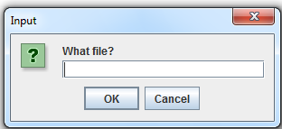
Objective
Reading and parsing lines of a text file.

Background
Up to now, the text file has always contained one item (either a word or a number) per line. You used next or nextInt to read that item (up to white space) and return it.
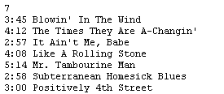
This time, we will have mixed data, both words and numbers—this can be tricky to read correctly. Each line will provide data for three different fields in the Song object. We have to read the entire line as a single string and then parse the string into its parts, either words or numbers. Scanner's method nextLine is the method we want. The file at the right is "dylan.txt". Study it.

The first line, which contains an integer, tells how many songs are to be processed. Here is good advice: If you have to use nextLine in one part of the program, use nextLine all the way through. It is better not to mix infile.nextInt and infile.nextLine, although the lab can be done that way.

Read each subsequent line and process it into two integers and a string that represent the song's minutes, seconds, and title. The number of minutes might be either one or two digits (or three digits, ahh!). Therefore, you will have to search for the colon to figure out where the minutes end. The number of seconds will always be two digits. The title always starts one space after the seconds end. Clearly the format of the input file is very specific.

The output is the total time of all the songs in the list and the name of the longest song, followed by its time:

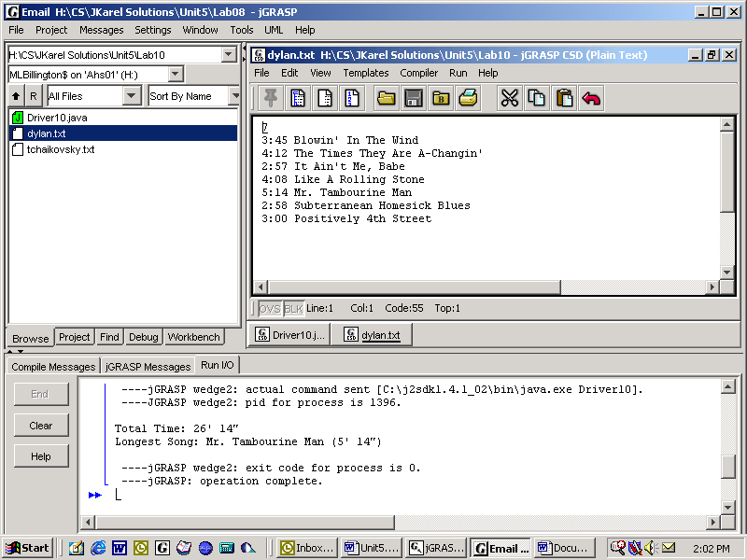

Do some top-down planning. What will be the methods in main?

As is typical in object-oriented programming, we decide to make an object that accomplishes some of our tasks. In this case, we will be working with Song objects. What private data should a Song object know? What methods would be useful in a Song object? Would it be useful if the Song class implemented the Comparable interface?

Specification
Filename Unit5\Lab10\Driver10.java. Use a JOptionPane to prompt the user for the file name.
Filename Unit5\Lab10\Song.java.
Filenames Unit5\Lab10\dylan.txt, \tchaikovsky.txt, \beethoven.txt
Test Data
Go to http://academics.tjhsst.edu/compsci/CSweb/index.html

Discussion
Recursion and Computations
In general, a recursive structure has substructures that have the same form as the original structure. In computer science, recursion is a technique in which a method calls a "one-step smaller" copy of itself. A recursive method calls itself, but recursion is not a loop! Instead, the recursive calls stack up until they reach the base case, which is where the recursion stops. Then the stacked up calls return to the previous calls, in reverse order, until the original method ends.
Calculating factorials is an example of recursion. Recall that 4! means 4*3*2*1 = 24. In math, the recursive definition is n! = n * (n – 1)!. Notice that n! is defined in terms of (n-1)!

public static long factorial(int n) | 1
{ | 1
if(n==1) | 2 * factorial(1)
return 1; | 2
else | 3 * factorial(2)
return n * factorial(n-1);
} | 4 * factorial(3) 6
System.out.println(factorial(4)); | factorial(4) 24

- Notice the if-else construction. All recursive methods have it, sometimes implicitly.
- Notice the call, at the end, to a “one-step smaller” copy of itself. Learn to look for it.
- Notice the base case, in the if-statement, which is where the recursion stops.
- The recursive calls stack up on top of one another. Until you get good at "seeing" the recursive structure, learn to trace the calls up and down the levels. The trace above shows how 4! returns 24.

Another common example of recursion is generating the Fibonacci sequence, which is defined by:
a) The first two numbers are both one.
b) Each subsequent number is equal to the sum of the two numbers directly preceding it.
This gives us the familiar sequence:
 | 1 | 1 | 2 | 3 | 5 | 8 | 13
0 | 1 | 2 | 3 | 4 | 5 | 6 | 7 | 8 | 9 | 10

1. Why is the Fibonacci function naturally recursive?

2. What are the base cases?

3. What are the recursive calls?

You should understand that in practice, calculating the Fibonacci number recursively is terribly inefficient because we end up calculating the first two values way more than we need to. In fact, it would be more efficient to use iteration and an array:

int[] array = new int[n];
array[1] = array[2] = 1;
for(int k = 3; k < n; k++)
array[k] = array[k – 1] + array[k – 2];

Nevertheless, in other problem-spaces, recursion is faster and more convenient than iteration. Recursion is an extremely powerful tool for dealing with problems that are branching, tree-like, or nested.

Lab11
Recursive Computations
Objective
To use recursion in a computation.
Background
It's actually quite easy to make up a function that is recursive. Let's define an arbitrary function f such that
f(1) = 7 and f(n) = f(n – 1) + 9. Then f generates a table:
n | 1 | 2 | 3 | 4 | 5 | 6 | 7
f(n) | 7 | 16 | 25 | 34 | 43 | 52 | 61

Our function f could of course be calculated explicitly as:  public static int f(int n)  {  return 7 + (n – 1) * 9;  } | The recursive version of function f is given by:  public static int f(int n)  {  if(n == 1)  return 7;  else  return 9 + f(n – 1);  }  Notice the recursive call and the base case.
Powers: How do you calculate powers, for example 2³? 2³ = 2 * 2². But 2² = 2 * 2¹. Finally, 2¹ = 2. This leads to a recursive definition for powers:
base if exp = 1
base^{exp} = base * base^{exp – 1} if exp > 1

GCD: A gcd function can use recursion to find the Greatest Common Divisor of two integers. The gcd of 12 and 8 is 4, i.e., the largest integer that divides evenly both 12 and 8. Thus, gcd(17,10) → 1 and gcd(18, 12) → 6. Here is Euclid’s algorithm to calculate the gcd of two integers x and y:

gcd(x,y) → x if x goes evenly into y, else
gcd(x,y) → y if y goes evenly into x, else
gcd(x,y) → gcd(y, remainder of x/y);

Specification
Filename Unit5\Lab11\Driver11.java. Modify the shell. Write methods to calculate 1) powers, 2) factorials, 3) Fibonacci numbers, and 4) GCD.
Extension
Other good recursive projects include 5) Superprimes, 6) white-black erase, 7) a palindrome checker, 8) the Knight's Tour, and 9) the 8-Queens problem.
Test Data
Go to http://academics.tjhsst.edu/compsci/CSweb/index.html

Exercises
Lab11

- Evaluate f(6), given that:

f(x – 2) + 3, when x > 1
f(x) = 2, when x = 1
1, when x = 0 f(6) = _________

- Evaluate f(12, 6), given that:

f(x – y, y – 1) + 2, when x > y
f(x, y) =
x + y, otherwise f(12, 6) = _________

- Given the method,
public static int result( int num)
{
if( num == 1 )
return 1;
else
return num + result(num – 1);
}
what is the output of the following calls?

a. System.out.println( result(1) ); _________
b. System.out.println( result(2) ); _________
c. System.out.println( result(3) ); _________
d. System.out.println( result(4) ); _________

- Consider the following function
public void mystery(int x)
{
System.out.print((x % 10) + " ");
if ((x / 10) != 0)
mystery(x / 10);
}
What is printed as the result of the call mystery(1234)? ____ _____

- Consider the recursive method whose definition appears below.
public static String mysteryString(String s)
{
if (s.length() == 1)
return s;
else
return s.substring(s.length() - 1) +
mysteryString(s.substring(0, s.length() - 1));
}
What is the result of the following call?
System.out.println( mysteryString("computer") ); __________

Lab12
Folder Listing
Objective
To print files and directories recursively.
Background
The directories (folders) on your hard drive also demonstrate a recursive structure. Each subdirectory may be either a directory or a file. That's the recursive part.
This lab will print all the files and their pathnames in any given directory structure. First, prompt the user to enter the complete path of a directory, for instance, "C:\temp". Instantiate "C:\temp" as a File object f. Then call foo. The method foo implements a recursive algorithm for printing all the files in the directory structure, namely, if f is a directory, then make an array of the files, and recursively test whether each element in the array is a directory. If f is not a directory (that's the base case), then print the string representation of f.
How do you do all that? The File class has several helpful methods:
File(String pathname)
Creates a new File instance by converting the given pathname string into an abstract pathname.
boolean |  | isDirectory()  Tests whether the file denoted by this abstract pathname is a directory.
File[ ] | listFiles()  Returns an array of abstract pathnames denoting the files in the directory denoted by this abstract pathname.
String | getPath()  Converts this abstract pathname into a pathname string.
If your code is correct, your program prints out all the documents contained either directly in C:\temp or in any one of C:\temp's subdirectories, or their subdirectories, or their subdirectories, and so on. (Warning, you may want to test your program with a directory that will have fewer total files than C:\temp.) Since there may be quite a lot of files to list, redirect your output to a text file rather than to the command window.
Specification
Filename Unit5\Lab12\Driver12.java. Complete the foo method.
Test Data
Go to http://academics.tjhsst.edu/compsci/CSweb/index.html . Since web applets, for security reasons, won't let just anyone search the hard drive, the applet code gives you a typical output for c:\j2sdk1.4.1_02. Here is part of the list of files in my computer's current c:\temp:
c:\temp\System32\drivers\drivers\vsapint.sys
c:\temp\System32\drivers\TMFilter.sys
c:\temp\System32\drivers\tmpreflt.sys
c:\temp\System32\drivers\tmtdi.sys
c:\temp\System32\drivers\VSAPINT.SYS
c:\temp\!db_pcc.dat
c:\temp\license.rtf
c:\temp\PCC.exe
c:\temp\setup.exe

Exercises
Lab12

1. What is output by the call fun(3)? __________
public void fun(int x)
{
if (x>=1)
{
System.out.print(x);
fun(x-1);
}
}

2. Consider the following method:
public void mystery (int a, int b)
{
System.out.print (a + " ");
if (a <= b)
mystery (a + 5, b - 1);
}
What is the output when mystery(0, 16) is called? ___________

3. Consider the following method:
public int change(int value)
{
if(value < 3)
return value % 3;
return value % 3 + 10 * change(value/3);
}
What will be returned by the call change(45)? ___________

4. What is output by the call fun(3,6)? ____________
public int fun(int x, int y)
{
if (y == 2)
return x;
else
return fun (x, y-1) + x;
}

5. Consider the following method:
public static String mysterio(String str)
{
int len = str.length();
if (len >= 1)
return str.substring(len/3, 2*len/3) + mysterio(str.substring(0, len/2));
return "";
}
What is the output of System.out.print(mysterio("la-da-pa!")); _________

Lab13
Towers of Hanoi
Objective
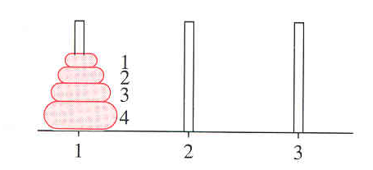
To solve a classic problem in recursive thinking.
Background

We have 3 pins and a tower of disks, smaller on top of bigger, on the first pin. The purpose of the puzzle is to move the whole tower from the first pin to the second, by moving only one disk every time and by taking care not to put a bigger disk on top of a smaller one.

Thinking recursively, we would say that moving 3 disks means we need to move 2 disks. Moving 2 disks means we need to move 1 disk. Moving 1 disk is easy, so let’s print that move. Then the recursion, all by itself, goes back up the levels, moving each disk in turn. Moving a tower of disks is just like moving the one-step smaller tower. Recursion!

Print out the sequence of movements necessary to move N disks from one pin to the other. Your code will contain exactly one (1) System.out.println statement, which happens to be called every time you move one disk. Your code will call tower twice, each time decreasing the number of disks. The base case can be, if the number of disks equals 0, then return. Alternatively, the implied base case can be, if N>=1, move.

The first call to tower is: tower(1, 3, 2, number);

The header of the tower method is:

public static void tower(int start, int finish, int helper, int number)
so that the start pin is 1, the finish pin is 3, and the helper pin is 2. Here are two sample runs:

Sample run, n = 3 Sample run, n = 4
Move disk 1 from 1 to 3. Move disk 1 from 1 to 2.
Move disk 2 from 1 to 2. Move disk 2 from 1 to 3.
Move disk 1 from 3 to 2. Move disk 1 from 2 to 3.
Move disk 3 from 1 to 3. Move disk 3 from 1 to 2.
Move disk 1 from 2 to 1. Move disk 1 from 3 to 1.
Move disk 2 from 2 to 3. Move disk 2 from 3 to 2.
Move disk 1 from 1 to 3. Move disk 1 from 1 to 2.
Move disk 4 from 1 to 3.
Move disk 1 from 2 to 3.
Move disk 2 from 2 to 1.
Move disk 1 from 3 to 1.
Move disk 3 from 2 to 3.
Move disk 1 from 1 to 2.
Move disk 2 from 1 to 3.
Move disk 1 from 2 to 3.
Specification
Filename Unit5\Lab13\Lab13.java.
Using recursion, print the sequence
of moves.

Extension
Display the solution graphically.

Test Data
Go to http://academics.tjhsst.edu/compsci/CSweb/index.html

Exercises
Lab13

1. What is output by the call fun(3)? _________
public int fun(int x)
{
if (x<1)
return x;
else
return x + fun(x-1);
}

2. What is the output when mysterySum(6) is called? __________
public int mysterySum(int a)
{
if (a <= 1)
return 1;
else
return 10 + mysterySum(a – 2);
}

3. Consider the following method:
public int getSomething(int value)
{
if(value < 1)
return 0;
else
return 1 + getSomething(value – 1) + getSomething(value – 2);
}
What is returned by the call getSomething(4)? ________

4. Consider the following method:
public void change(int value)
{
if(value < 5)
System.out.print("" + value % 5);
else
{
System.out.print("" + value % 5);
change(value/5);
}
}
What will be printed as a result of the call change(29)? _________

5. What is output by the call fun(3)? ________
public void fun(int x)
{
if (x<1)
System.out.print(x+" ");
else
{
System.out.print(x+" ");
fun(x-1);
}
}
Lab14
Fractal Trees
Objective
To make the turtle draw fractal trees using recursion.
1 public class Driver11
2 {
3 public static void main(String[] args)
4 {
5 JFrame frame = new JFrame("Tree Turtles");
6 frame.setSize(400, 400);
7 frame.setLocation(200, 100);
8 frame.setDefaultCloseOperation(
JFrame.EXIT_ON_CLOSE);
9 frame.setContentPane(new TurtlePanel());
10 frame.setVisible(true);
11 Turtle smidge = new Turtle(300.0, 500.0, 90.0)
12 {
13 public void drawShape()
14 {}
15 };
16 smidge.setCrawl(true);
17 smidge.setSpeed(1);
18 int level = Integer.parseInt(
JOptionPane.showInputDialog(
"How many levels?"));
19 tree(smidge, 70.0, 30.0, level);
20 //treeExt(smidge, 70.0, 25.0); //extension
21 }
Background
Study the driver class.

Line 9 instantiates a TurtlePanel, which has a listener and a timer that repaint the screen.

Line 11: Recall that Turtle is an abstract class. Since we can't normally instantiate on object of an abstract class, we use a trick on lines 13 and 14 to get around that rule.

Line 19: The tree method, which you will have to write, uses the Turtle's instance methods forward, back, turnLeft, and turnRight.

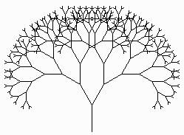
Recursion is a technique in which a method calls a "one-step smaller" copy of itself. Recursion is not a loop! The key is to see the "tree" as a line with two smaller "trees" coming out at different angles from the top. That is, the trunk, branches, and leaves are all just "trees" that get progressively smaller. Therefore we can program the whole tree-shape recursively as follows:
a. If the level reaches 0, then return;, which stops the recursion. This is the "base case," where the recursion stops.
b. In all other cases, have the turtle draw the trunk and call tree again, which will draw a smaller trunk coming out of it to the left. Somehow, call tree a second time to draw the trunks to the right. Try starting with a size of 70, each new trunk getting smaller by 10, and angles equal to 30°.

Specification
Filename Unit5\Lab14\Driver14.java. Write the recursive tree method.
Filename Unit5\Lab14\TurtlePanel.java. Don't change this class!
Extension
Change the code so that the tree stops when the size of the branches is less than 5. Don't use levels. Make the tree more realistic by using random (20° to 30°) angles and randomly decreasing (-5 to -15) branches. Write a setColor method to make the trunk black, the branches green, and the berries (i.e. the smallest branches) red.

Test Data
Go to http://academics.tjhsst.edu/compsci/CSweb/index.html
Discussion
Making Fractals
The tree in Lab11 is an example of a fractal, defined as "a rough or fragmented geometric shape that can be split into parts, each of which is (at least approximately) a reduced-size copy of the whole." The definition of fractals makes clear that fractals are naturally recursive.

Some famous fractals include the Mandelbrot set, the Julia set, the Sierpinski triangle, and the Koch snowflake. With our Logo turtle, it is easier to draw a fractal Koch line, which can be repeated to make the Koch snowflake. Here is the algorithm: begin with a Koch segment. Replace it with 4 smaller (one-third as big) Koch segments. Turn so that two of those smaller Koch segments form a "spike." Then recur on each and every Koch segment, ad infinitum.

In other words, your program should produce the following fractal shapes at the given level:
Level = 0 | 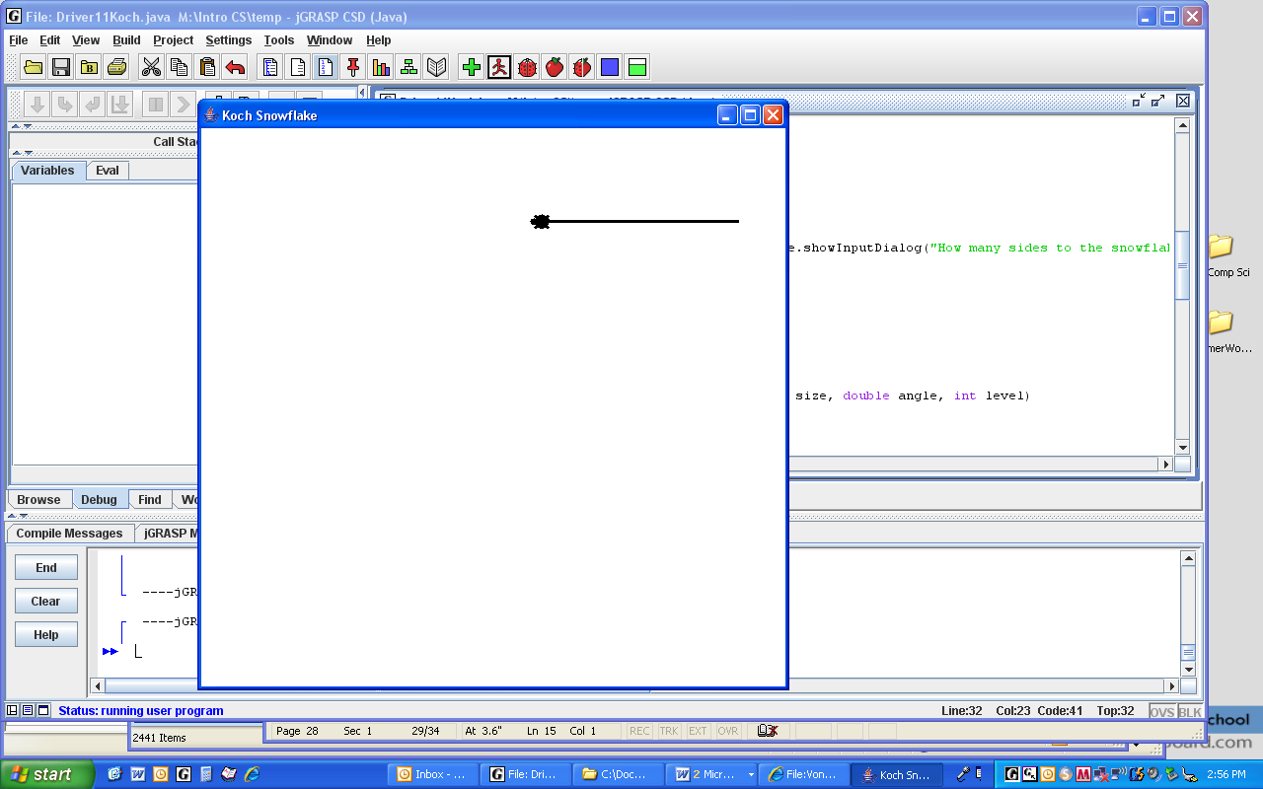 | A Koch segment
Level = 1 | 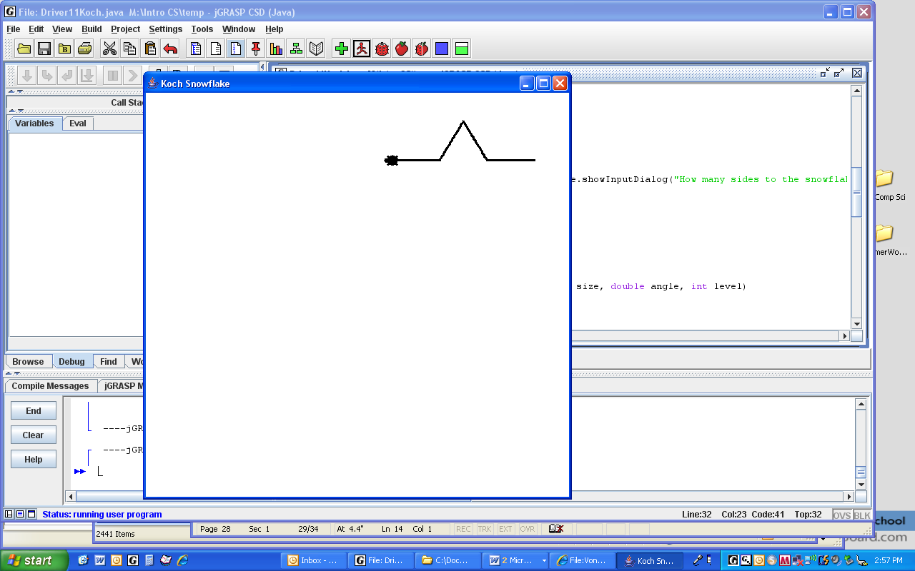 | 4 smaller (one-third the size) Koch segments
Level = 2 | 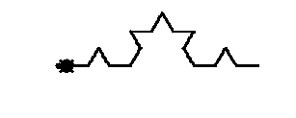 | Each and every segment has 4 smaller Koch segments.
Level = 3 | 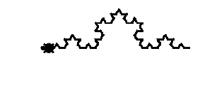 | Recur ad infinitum.
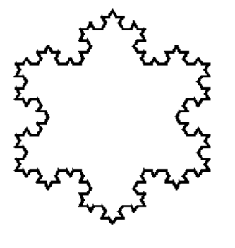
When that is working, you can repeat the level 3 Koch line to produce
a Koch snowflake.

Did you know that Koch snowflakes have a finite area and an infinite perimeter? Amazing!

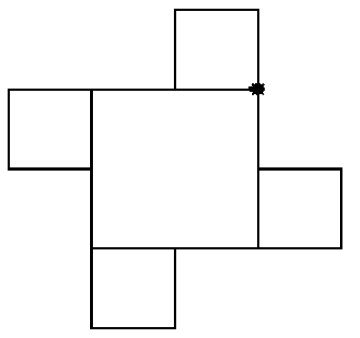

How about producing this fractal? It looks like the large square has half-size squares at each corner.

Level 0, the base case, produces nothing.
Level 1 produces only the large square.
Level 2 is shown to the right.
What would the Level 3 fractal look like? Draw it here.

Lab15
1 | Adams, J
2 | Adams, J. Q.
3 | Arthur
4 | Buchanan
5 | Bush, G.
6 | Bush, G. W.
7 | Carter
8 | Cleveland
9 | Clinton
10 | Coolidge
11 | Eisenhower
12 | Fillmore
13 | Ford
14 | Garfield
15 | Grant
16 | Harding
17 | Harrison, B.
18 | Harrison, W.
19 | Hayes
20 | Hoover
21 | Jackson
22 | Jefferson
23 | Johnson, A.
24 | Johnson, L.
25 | Kennedy
26 | Lincoln
27 | Madison
28 | McKinley
29 | Monroe
30 | Nixon
31 | Pierce
32 | Polk
33 | Reagan
34 | Roosevelt, F
35 | Roosevelt, T
36 | Taft
37 | Taylor
38 | Truman
39 | Tyler
40 | Van Buren
41 | Washington
42 | Wilson

Binary Search
Objective
To implement the binary search.

Background
A linear search uses a loop to examine each item in an array until a certain target is found. For instance:
public static int search(String[] array, String target)
{
for(int k = 0; k < array.length; k++)
if( array[k].compareTo( target ) == 0 )
return k;
return -1;
}
For n items, this requires n operations in the worst case, i.e. when the target is not in the array. Whether the array is sorted or not, the linear search still has a worst case of n operations. Fortunately, if the array is already sorted, we can get a much better speed than n operations, if we use the Binary Search.

Most people rely on the Binary Search when looking up a name in a phone book, or a word in a dictionary. They open the book near the middle, compare, then choose the half of the book in which to look again. In other words, they discard half of the data each time by continually checking the middle item from the data set still needing to be searched. At each step, half the data is discarded. The number of steps k is related to n elements by the equation n = 2^{k}. Take the log of both sides to get k = log₂ n.
Length of list n | Maximum number of steps k
 | Linear | Binary
1 | 1 | 1
3 | 3 | 2
7 | 7 | 3
15 | 15 | 4
31 | 31 | 5
63 | 63 | 6
127 | 127 | 7
255 | 255 | 8
511 | 511 | 9
1023 | 1023 | 10
n | n | log₂ n

Therefore in the worst case a binary search needs only log n comparisons while a linear search requires n comparisons. Examine the table at the left. Binary Searches are much faster than linear searches.

Given 42 different presidents, in alphabetical order, how many steps does it take to find "Madison"? To find "Fillmore"? How will the computer decide that "Obama" is not in the list?
In your own words, write the algorithm for the Binary Search.

Specification
Filename Unit5\Lab15\data.txt. The data is decimal numbers formatted to one decimal place, 0.0 <= x < 10.0. You may generate a different set of numbers if you run MakeDataFile.java.

Filename Unit5\Lab15\Driver15.java. Implement both the linear search and the binary search. (You may implement the binary search either recursively or iteratively.) Count how many steps it takes to find the target.

Test Data
Go to http://academics.tjhsst.edu/compsci/CSweb/index.html

